TERM 3 2022 TEACHMEETS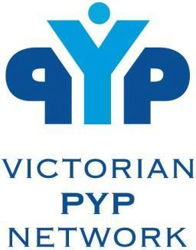

Dear PYP Coordinators and Teachers,

This term we will have another session for all teachers to get back together online and share their wonderful learning engagements, actions and successes from the year so far.

We have received some requests to host this meeting slightly earlier so that teams can stay at school and participate. Our next round of TeachMeets (next year) will be held at a slightly later time to allow participants to return to their homes for the session.

This session is happening on **Thursday 11 August 2022 from 3:45- 5:15pm.**

***The success of TeachMeets depends on presentations of 2 or 7 minutes from a variety of schools. Presenters will be able to share in small groups, pairs or individually.***

**Registrations for presenters and participants are open from NOW until Tuesday 9 August 4pm**

[CLICK HERE TO REGISTER AS A PRESENTER OR A PARTICIPANT](https://forms.gle/tUDsUn9c3ZUSn7um7)

A Zoom link for the meeting will be shared on Thursday morning.

In order to enhance the reciprocal nature of TeachMeets, we encourage schools that are planning on joining as participants to also provide a presenter.

We look forward to seeing you soon!

Claire Van Loon and Geoff Geddes

Co-chairs of Professional Development.