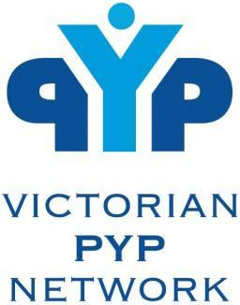
TERM 1 2023 TEACHMEETS

Wominjeka PYP Colleagues,
TeachMeets are back for 2023!
The Victorian PYP Network is pleased to invite you to our Term 1 Virtual Teachmeet.
We will be hosting two sessions during Week 9 of Term 1.
Tuesday 28th March and Thursday 30th March.
All presentations will be held via Zoom from 4pm-5:30pm
The session will have approx. 10-12 presentations of 2-7 minutes each and an opportunity to ask questions at the end of each presentation.
The success of TeachMeets depends on presentations of 2 or 7 minutes from a variety of schools. Presenters will be able to share in small groups, pairs or individually.

Registrations for presenters are open from NOW until FRIDAY 24 MARCH.
CLICK HERE TO REGISTER AS A PRESENTER
The ‘Theme’ of the session is ‘This Works for Me’ and is an opportunity for you to share any strategies, routines or structures you have in place for planning, delivering, collaborating, assessing and sharing the PYP in your School. Of course, presentations are not limited to this theme!
Our aim is to have a range of presenters and their topics listed on the Google link, in order for participants to be able to see the areas in advance.

You will then be able to use the Zoom Link to join the meeting on 28 and 30 March at 4:00pm but in order to enhance the reciprocal nature of TeachMeets, we encourage schools that are planning on joining as participants to also provide at least one presenter.

We look forward to seeing you soon!

Karen Chaur and Geoff Geddes

